CLIL: From Colonialism to the Decolonisation Era

15th to 20th centuries

**Name**: Markus Kattner

|  |  |  |
| --- | --- | --- |
| **Topic** | **Task** | **Points** |
| **COLONIALISM / AGE OF DISCOVERY** | Task 1-1 | /2 |
| Task 1-2 | /2 |
| Task 1-3 | /2 |
| **IMPERIALISM** | Task 2-1 | /2 |
| Task 2-2 | /2 |
| **DECOLONISATION &**  **NORTH-SOUTH DIVIDE** | Task 3-1 | /4 |
| **EXTRA** | Extra task 1 | /2 |
| Extra task 2 | /2 |
| **TOTAL** | | **/14** |

# COLONIALISM / AGE OF DISCOVERY

## TASK 1: Read the texts on early colonialism and…

1. Identify 7 key words in the texts which relate to the topic of colonialism
   * **Colonies**
   * **Trade outposts**
   * **God, gold, glory**
   * **Caravel**
   * **Columbian Exchange**
   * **Conquistadores**
   * **Triangular trade**
2. Explain the three main motives for European exploration in your own words.
3. **God**: Religious zeal to spread Christianity, especially after the Crusades.
4. **Gold**: Desire for wealth through spices, resources, and avoiding Ottoman trade taxes.
5. **Glory**: National prestige from territorial expansion and rivalry (e.g., Portugal vs. Spain).

3)Summarise the ‘triangular trade’ model in your own words.

1. **Europe → Africa**: Manufactured goods (e.g., weapons) traded for enslaved people.
2. **Africa → America**: Enslaved Africans transported ("Middle Passage") for plantation labor.
3. **America → Europe**: Raw materials (e.g., sugar, cotton) shipped for industrial processing.

**EXTRA:** The text explains some of the major consequences for the inhabitants of the colonised territories. Can you think of additional consequences for the Europeans themselves?

* **Economic growth**: Cheap resources fueled industrialization (e.g., textiles).
* **Scientific advances**: Improved navigation (astrolabe) and cartography.
* **Cultural exchange**: New crops (potatoes/maize) revolutionized diets.
* **Geopolitical conflicts**: Wars over colonies (e.g., Anglo-French rivalry).

# IMPERIALISM

Imperialism refers to a historical phase which reached its peak during the 19th and early 20th century. Imperialism had an even greater impact on the extension of military, political and economic spheres of influence than colonialism. Thus, 'Imperialism' (lat. imperium = empire) is the process in which the objective is to win power and influence in the world, at the expense of other, non-European peoples. European imperialism was marked by racism, increasingly fierce nationalism, and a sense of mission which originated from these two factors. Basically, it relied on the law of the jungle. Various European countries had a strong ambition for extending their power. It became more or less a race to the territories in Africa (→ ‘Scramble for Africa’) and Asia which had not yet been colonized. Their own colonial areas had to be increased at the expense of other powers. The colonial powers' desire for raw materials and natural resources from the colonies was also stimulated by the Industrial Revolution.

## TASK 2: Read the definition on imperialism above, analyse the sources given on the additional handout and …

1)Discuss the difference between ‘colonialism’ and ‘imperialism’.

| **Colonialism** | **Imperialism** |
| --- | --- |
| Direct control of territories (e.g., settlements). | Indirect dominance (e.g., economic influence). |
| Driven by trade/resources (15th–18th c.). | Fueled by nationalism/racism (19th c.). |
| Example: Spanish viceroyalties in America | Example: British "sphere of influence" in China. |

2)Find examples of the ‘sense of mission’, ‘fierce nationalism’ and ‘the objective to win power and influence’ in the sources given on the handout and briefly explain your choices.

1. **Sense of mission**:  
   Cecil Rhodes: *"Paint as much of Africa British Red as possible"* → Belief in "civilizing duty."
2. **Fierce nationalism**:  
   *"Rule, Britannia!"* lyric: *"Britons never shall be slaves"* → Naval supremacy as national pride.
3. **Objective to win power**:  
   Lord Macaulay: Creating English-educated Indian elites → Cultural domination as control tool.

**EXTRA**: **The Scramble for Africa**. Provide a brief analysis of the following caricature showing German chancellor Bismarck and other imperial powers around a ‘cake’ of Africa.

* + What did the author try to show?
    - **Author’s message**: Satire of greedy, arbitrary partition ignoring ethnic boundaries ("cake" = exploitation).
  + Do you think the author was rather pro or against imperialism?
    - **Author’s stance**: **Anti-imperialist** (critiques power rivalry + dehumanization of Africa).

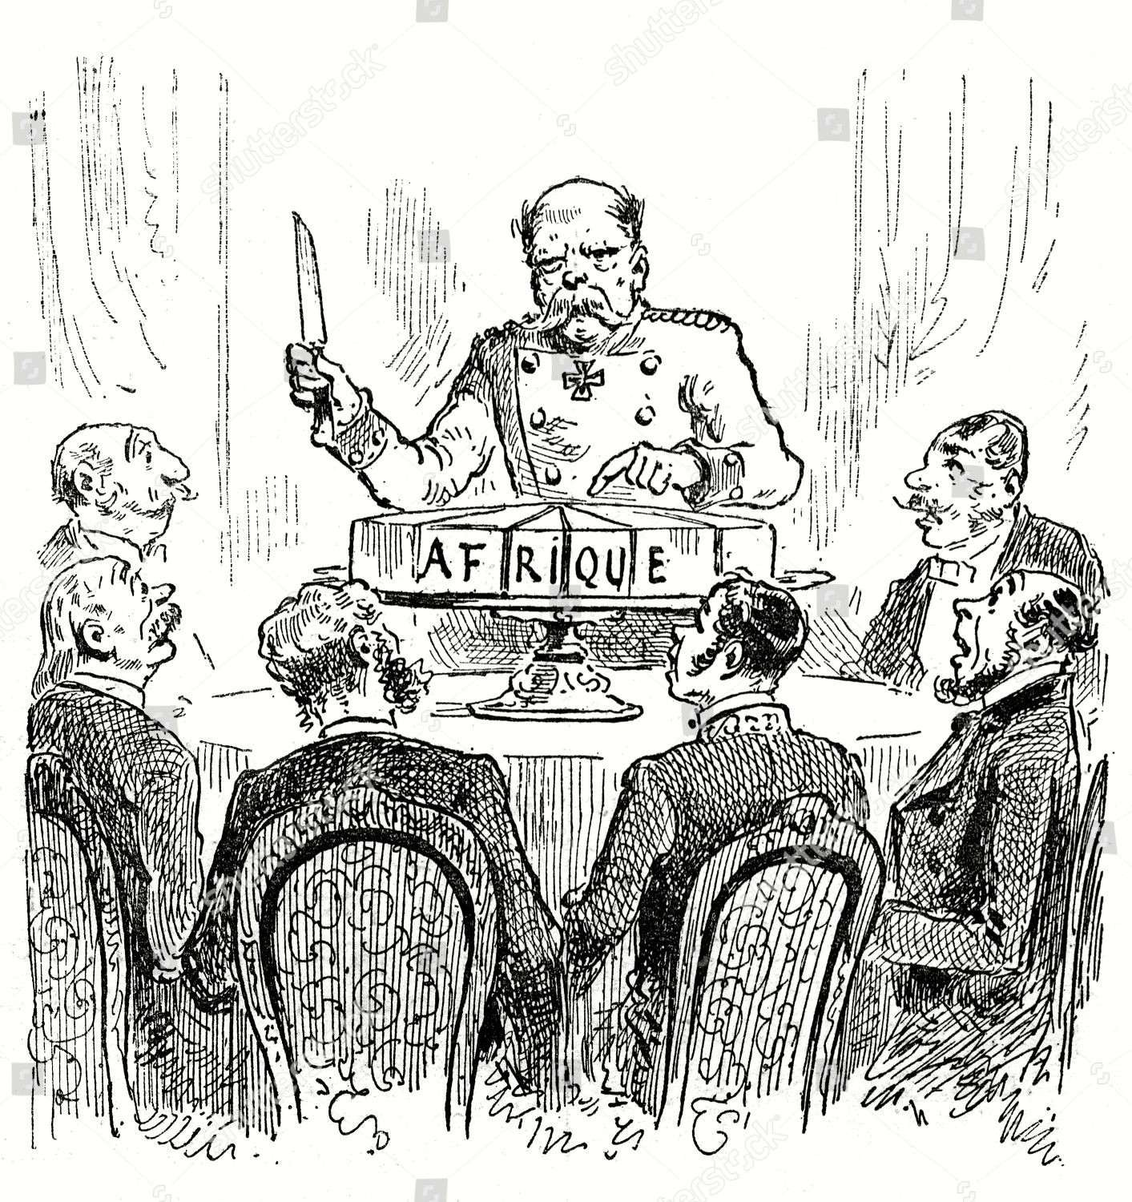

# DECOLONISATION AND THE NORTH-SOUTH DIVIDE

## TASK 3: Create an infographic summarising the lasting effects of colonialism.

Use the caricatures on the handout as a starting point and make use of the glossary at the end if you are in need of important vocabulary.

[Visual: Split globe showing wealthy North/poor South]

1. ARTIFICIAL BORDERS

- Ethnic conflicts (e.g., Nigeria-Biafra War).

- Source: "Europeans did not care about indigenous groups when tracing borders."

2. ECONOMIC DEPENDENCY

- "Core-periphery" resource flow (Dependency Theory).

- Unstable commodity economies (e.g., cash crops).

3. POLITICAL INSTABILITY

- Corrupt elites + post-independence wars (e.g., Algeria).

- Legacy of colonial administration.

4. NORTH-SOUTH DIVIDE

- Wealth gap: Industrialized North vs. commodity-dependent South.

- Source: "Socio-economic/political divide."

**GLOSSARY SUPPORT**

*(Relevant terms for tasks)*

* **Triangular trade**: Atlantic slave trade system (Europe → Africa → America).
* **Chartered company**: Entities like East India Company for colonial trade.
* **Scramble for Africa**: 1881–1914 division of Africa by Europeans.
* **Balfour Declaration**: 1917 British pledge impacting Palestine.
* **Dependency theory**: Resources flow from poor "periphery" to wealthy "core."

**GLOSSARY – AGE OF DISCOVERY (*Zeitalter der Entdeckungen*)**

|  |  |
| --- | --- |
| adventurer (n.) | someone who goes on an exciting and sometimes dangerous  experience |
| astrolabe (n.) | a circular device used for measuring the position of starts,  and on ships for calculating the ship’s position |
| caravel (n.) | a small sailing ship which was easy to maneuver; developed  in the 15th century by the Portuguese |
| cartography (n.) | the science of art of making or drawing maps |
| charter (n.) | a formal statement of rights of an organisation or particular  group agreed by a ruler |
| chartered company (n.) | association formed by investors for the purpose of trade,  exploration, and colonisation; e.g. East India Company (est. 1600) |
| circumnavigation (n.) | the act of sailing or navigating around something, e.g. the  circumnavigation of Africa |
| Columbus Day | national holiday in many countries of the Americas celebrating the anniversary of Christopher Columbus’ arrival (October 12  or second Monday in October in the US) |
| discovery (n.) | the process of finding information, a place, or an object, especially for the first time  → discoverer (n.) / to discover (v.) |
| exploitation (n.) | the act of treating someone unfairly, e.g. to not pay or reward someone enough, to use or develop something for your advantage  → to exploit (v.) |
| exploration (n.) | the activity of searching and finding out about something  → explorer (n.) / to explore (v.) |
| Fall of Constantinople | capture of the capital of the Byzantine Empire by an invading  Ottoman army in 1453 |
| genocide (n.) | the intentional killing of a large group of people who belong to  a particular ethnic group or country |
| Jacob’s staff | a stick or pole with markings used in astronomy and  navigation to measure angles (later replaced by sextants) |
| landfall (n.) | the first land that is reached or seen at the end of a journey  across the sea or through the air, or the fact of arriving there |
| sailor (n.) | a person who works on a ship, especially one who is not an  officer |
| spice (n.) | a substance made from a plant, used to give a special flavour  to food; e.g. pepper, ginger, salt… |
| triangular trade (n.) | historical term indicating trade among three ports or regions;  the best-known trading system was the Atlantic slave trade |
| **USEFUL EXPRESSIONS/PHRASES:**  **the sea route to India** – der Seeweg nach Indien  **to fit out ships** – Schiffe ausrüsten  **to calculate the course of the ship** – den Kurs des Schiffes berechnen/bestimmen  **to find a direct sea route to Asia** – eine direkte Seeverbindung nach Asien finden  **to control the overland trade route** – die Handelsstraßen auf dem Landweg kontrollieren  **to round (the Cape of Good Hope)** – (das Kap der Guten Hoffnung) umrunden | |

**to explore new continents** – neue Kontinente erkunden

**to sight land / to spot land** – Land sichten

**AGE OF IMPERIALISM**

|  |  |
| --- | --- |
| Berlin Conference | conference held in Berlin in 1884-85 which regulated European colonisation in Africa  → also: “Congo Conference” |
| conquest (n.) | the act of taking control or possession of a foreign land, or a group of people, by force  → conqueror (n.) / to conquer (v.) |
| extend (v.) | to add to something in order to make it bigger or longer  → extension (n.) |
| extol (v.) | to say that you think that something is very good |
| naval power (n.) | a country which has a wide range of powerful military ships,  personnel and shore establishments |
| savage (n.) | offensive term for a person whose way of life is at a very early stage of development; often used by European colonial powers to  describe indigenous people of the colonised countries |
| Scramble for Africa | occupation, division, and colonisation of African territory by  European powers between 1881 and 1914 |
| **USEFUL EXPRESSIONS/PHRASES:**  **to acquire overseas territories** – überseeische Besitzungen erwerben  **the acquisition of colonies as markets** – der Erwerb von Kolonien als Absatzmärkte  **colonies as suppliers of raw materials** – Kolonien als Rohstofflieferanten | |

**DECOLONISATION**

|  |  |
| --- | --- |
| apartheid (n.) | a political system in which people of different ethnicities are separated, especially in the past in South Africa (1948-early 1990s) |
| Balfour Declaration (1917) | public statement issued by the British government during  World War I announcing support for the establishment of a ‘national home for Jewish people’ in Palestine |
| decolonisation (n.) | the process in which a country that was previously a colony  becomes politically independent |
| emerging country (n.) | a country with little industrial and economic activity  → developing country / Newly Industrialised Country (NIC) |
| independence movement (n.) | movements to achieve national independence and/or liberation, might be considered separatist or even terrorist depending on the situation  → national liberation movements |
| North-South Divide | a socio-economic and political divide between rich and  industrialised northern states and poorer developing southern states of the world |
| **USEFUL EXPRESSIONS/PHRASES:**  **right to self-determination** – Recht auf Selbstbestimmung | |